

Faculty Member: Huma Ghafoor Date: 4/13/2023

Semester: 6th Section: C

**EE-351 Communication Systems**

**Lab 9:**  **FREQUENCY MODULTION WITH MATLAB**

|  |  |  |  |  |  |  |
| --- | --- | --- | --- | --- | --- | --- |
|  |  | **PLO4-CLO4** | | **PLO5-CLO5** | **PLO8-CLO6** | **PLO9-CLO7** |
| **Name** | **Reg. No** | **Viva / Quiz / Lab Performance** | **Analysis of data in Lab Report** | **Modern Tool Usage** | **Ethics and Safety** | **Individual and Team Work** |
|  |  | **5 Marks** | **5 Marks** | **5 Marks** | **5 Marks** | **5 Marks** |
| **Muhammad Ahmed Mohsin** | **333060** |  |  |  |  |  |
| **Hassan Rizwan** | **335753** |  |  |  |  |  |
| **Syeda Fatima Zahra** | **334379** |  |  |  |  |  |
| **Amina Bashir** | **343489** |  |  |  |  |  |

Table of Contents

Lab Instructions 2

Lab Report Instructions 2

Introduction: 3

Tasks 4

Code 4

Code Snippet: 5

Output: 6

Conclusion: 6

**FREQUENCY MODULATION**

# Lab Instructions

* The students should perform and demonstrate each lab task separately for stepwise evaluation
* Each group shall submit lab report on LMS within 6 days after lab is conducted. Lab report submitted via email will not be graded.
* Students are however encouraged to practice on their own in spare time for enhancing their skills.
* Complete as many problems as you can within the allotted time.
* Talk to your classmates for help

# Lab Report Instructions

* All questions should be answered precisely to get maximum credit. Lab report must ensure following items:
* Lab objective
* Results (screen shots) duly commented and discussed.
* Conclusion

# Introduction:

Frequency modulation (FM) is the encoding of information in a carrier wave by varying the instantaneous frequency of the wave. The technology is used in telecommunications, radio broadcasting, signal processing, and computing. In analogue frequency modulation, such as radio broadcasting, of an audio signal representing voice or music, the instantaneous frequency deviation, i.e. the difference between the frequency of the carrier and its centre frequency, has a functional relation to the modulating signal amplitude. Frequency modulation is widely used for FM radio broadcasting. It is also used in telemetry, radar, seismic prospecting, and monitoring newborns for seizures via EEG, two-way radio systems, sound synthesis, magnetic tape-recording systems and some video-transmission systems. In radio transmission, an advantage of frequency modulation is that it has a larger signal-to-noise ratio and therefore rejects radio frequency interference better than an equal power amplitude modulation (AM) signal. For this reason, most music is broadcast over FM radio.

The message signal, such as an audio signal that is used for modulating the carrier, is m(t), and has a frequency fm, much lower than fc:

𝑚(𝑡) = 𝐴𝑚cos (2𝜋𝑓𝑚𝑡)

The carrier wave (sine wave) of frequency fc and amplitude A is expressed by

𝑐(𝑡) = 𝐴𝑐cos (2𝜋𝑓𝑐 𝑡)

The expression of modulated signal y(t), can be written as,

𝑦(𝑡) = 𝐴𝑐cos (2𝜋𝑓𝑐 𝑡 + B 𝑠𝑖𝑛 (2𝜋𝑓𝑚𝑡))

where 𝐴𝑚 is the amplitude of the modulating sinusoid is represented in the peak 𝑓∆ = 𝑘𝑓 ∗ 𝐴𝑚 deviation and 𝑘𝑓 is the sensitivity of frequency modulator.

# Tasks

* Generate a message signal of amplitude 1V and frequency 2Hz.
* Generate a carrier signal of amplitude 1V and frequency 20Hz
* Assume the value of sensitivity constant 𝑘𝑓 as 14. Generate a FM modulated signal using formulas.
* The time scale division should be as mentioned below:
* T=linspace(0,1,500);
* Change the Sensitivity constant and see if there are any changes in FM modulation.

# Code

% Hasan Rixwn 335753

% Ahmed Mohsin 333060

% Amina Bashir 343489

%Syeda Fatima Zahra 334379

% Define parameters

A_message = 1; % amplitude = 1V

f_message = 2; % frequency = 2Hz

A_carrier = 1;

f_carrier = 20;

% Define time vector

t = linspace(0,1,500); % time from 0 to 1 second in steps of 0.001

% Generate message signal waveform

message = A_message*cos(2*pi*f_message*t);

carrier = A_carrier*cos(2*pi*f_carrier*t);

% Message Signal Plot waveform

subplot(311); plot(t,message);

xlabel('Time (s)');

ylabel('Amplitude (V)');

title('Message Signal Waveform');

% Carrier Signal Plot waveform

subplot(312);

plot(t,carrier);

xlabel('Time (s)');

ylabel('Amplitude (V)');

title('Carrier Signal Waveform');

kf = 15;

delta_f = kf*A_message;

index = (delta_f)/(f_message) ;

F_modulating = A_carrier*cos((2*pi*f_carrier*t) + (index*sin(2*pi*f_message*t)) );

% Frequnecy Modulating Signal Plot waveform

subplot(313);plot(t,F_modulating);

xlabel('Time (s)');

ylabel('Amplitude (V)');

title('Frequnecy Modulating Signal Waveform');

# Code Snippet:

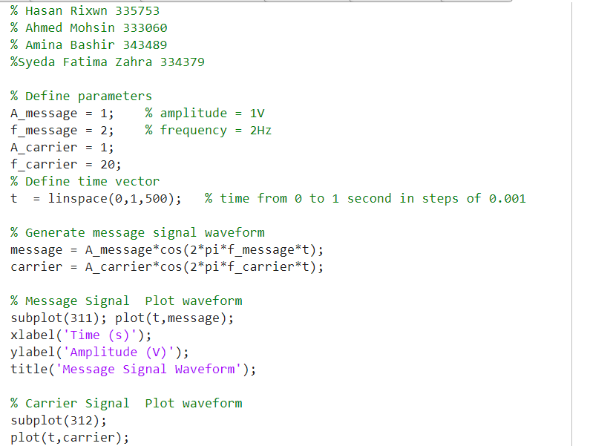

# Output:

# Conclusion:

In conclusion, the FM (Frequency Modulation) lab was a successful experiment in understanding the principles of signal modulation. Through the use of an FM transmitter and receiver, we were able to observe the effects of varying the frequency of the modulating signal on the modulated carrier wave. We also saw how changes in the modulation index can affect the signal's bandwidth and quality.